Final Report Group 1J

Program Requirements:

The goal of this program is to take a file of student information, and allow users to query the file through a menu of predetermined options. Through the program, the user is able to:

- Display all student records
- Display students whose last name begins with a certain string
- Display all records for students whose graduating year is a certain year
- Display a summary report of number and percent of students in each degree program, for students graduating on a certain year

Approach:

Our group approached this project in three phases: Design, Prototype, Refinement. In the design phase, we decided on the structure of the program. Importantly, the design described how the data would be structured in the program, and a potential list of functions and their inputs and outputs. In the prototype phase, we drafted the initial code for the program, ensuring that the program functioned at a basic level, and could perform the basic necessary functions. In the final refinement phase, we tested the program for errors and reinforced the code against potential break points. In addition, we implemented the final summary statistics function.

Design of the program: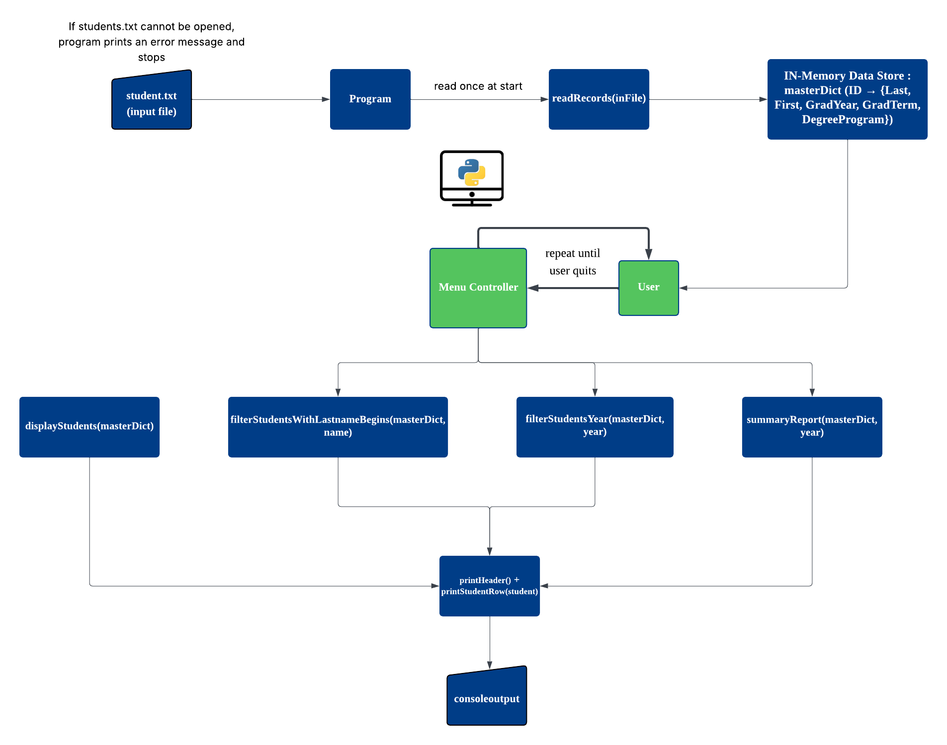
Use of AI:

We used AI to improve the formatting of our console output, specifically for the functions responsible for printing student information. Initially, the program printed dictionary objects in raw form, which made the output difficult to read. We asked the AI how to create a clean, tabular layout using Python’s format() method, which led to the development of:

- printHeader(): formats the table headers into fixed-width columns
- printStudentsRows(): prints each student’s data aligned under those columns

We prompted AI with the code to conduct a code review and suggest places to implement error handling. This directed us towards the following potential issues, and offered possible solutions:
- readRecords(inFile) – handle bad files / bad lines
  - Empty file / missing header
  - Lines with wrong number of columns
  - Missing or duplicate IDs
- File loading – handle missing/invalid files, no menu if nothing loaded
- Year handling – validate user input & guard against bad data\
  - Helped to update functions summaryReport and filterStudentsYear
  - Suggested new helper function getYearFromUser, to help avoid user entry errors
- Last-name search – handle empty prefix & missing field
- EOFError exception in the menu function

We also prompted the AI to write a brief user guide for the program:
Student Records Query Program — User Guide
This program enables users to access and analyze student information stored in a tab-delimited text file. The application provides a structured menu interface for querying the dataset, allowing users to retrieve and summarize student records based on specified criteria. The input file must contain student entries with the following fields: ID, Last, First, GradYear, GradTerm, and DegreeProgram.
Program Initialization
Upon execution, the program prompts the user to enter the name of the data file. A filename may be provided manually, or the user may press Enter to load the default file “students.txt”. Once the file is successfully processed and records are read, the main menu is displayed.
Menu Options and Functionality
- 1 – Display All Students
This option outputs the complete list of student records in a formatted table view.
- 2 – Search by Last Name Prefix
The user is prompted to input the beginning of a student's last name. Any record whose “Last” field begins with the entered prefix will be displayed. If no matching entries exist, the program will report that no results were found.
- 3 – Search by Graduation Year
The user may specify a four-digit year to retrieve all student records with a corresponding “GradYear”. If invalid (non-numeric) input is supplied, the program will request a properly formatted year. If no records correspond to the specified year, a message indicating the absence of matching results will be shown.
- 4 – Summary Report by Graduation Year
This option produces a statistical summary of students graduating in the specified year, showing both the number and percentage of students in each degree program represented within that graduating cohort.
- quit – Exit Program
This option terminates the program.
Input Expectations and Error Handling
The program validates user input and responds appropriately to improper entries, ensuring that incorrect data formats do not cause program failure. Missing or malformed lines in the data file are disregarded and reported. Duplicate student IDs are flagged, and student records containing incomplete information are safely managed. The program ensures a controlled and stable execution environment.
Takeaways:

This project demonstrates the successful development of a functional and user-friendly system for querying student records from a structured text file. It highlights file processing, nested dictionary utilization, and menu-driven user interaction. The program incorporates error handling and input validation, ensuring stability even when encountering data irregularities or unexpected user input. Developing the project in three phases proved helpful to ensure a solid program structure and flow of functions. A key takeaway was the usefulness of utilizing Artificial Intelligence (AI) to review code and solve tricky issues. For example, through asking AI, the team was able to enhance the user experience, transforming raw data output into a clean, professional tabular format using the printHeader() and printStudentsRows() functions, as well as reinforcing code stability by suggesting critical error points and exception handling solutions in key areas like file reading, year validation, and menu handling. These efforts ensured that the final product not only met the data querying requirements but was also secured against failures and user-friendly for student records analysis.

Citations:

OpenAI. (2025). ChatGPT (November 5.1 version) [Large language model].
https://chat.openai.com/chat

